SHRI RAMDEOBABA COLLEGE OF ENGINEERING AND MANAGEMENT, NAGPUR.



ELECTRONIC WORKSHOP LAB

MINI PROJECT REPORT

(6TH SEM, SESSION 2021-2022, ECP358)

**“Density Based Traffic Signal System”**

Submitted By

Parth Vishwas Bhalerao (Roll No.-65, Sec-A)

Guide Name: Prof. Nishant Borkar

Workshop Coordinator: Dr. D G Khushalani / Prof. V S Lande

Page|1

**Department of Electronics and Communication Engineering**

**Contents**

1. **Introduction Pg No. 3**
2. **Impact of Project on society and the environment Pg No. 3**
3. **Block diagram and Functional description Pg No. 4**
4. **Circuit diagram and its description Pg No. 5**
5. **PCB layout and Artwork Pg No. 8**
6. **Working of Project Pg No. 9**
7. **Code Implementation and Flowchart Pg No. 11**
8. **Result and Future Scope Pg No. 13**
9. **References/ Citations Pg No. 14**

Page|2

1. **Introduction**

Over the years the number of vehicles has increased drastically, which has led to serious problems like traffic jams, accidents and many other similar issues.

In recent years traffic jams have become one of the challenges for engineers and designers to create an intelligent traffic light control system capable of detecting and reducing overall traffic density in the urban area. Through this project we proposed an intelligent traffic control system which includes a sensor-based network connected to an IOT platform.

1. **Impact of Project on society and the environment**

* By enhancing the flow of traffic, it will reduce the regular conjunction in the prime area.
* This means less waiting time at intersection and lower emission which ultimately led to less air pollution
* Effective Traffic management will lead to better utilization of transportation infrastructure and along with this it can also help in minimizing the accidents.

Page|3

1. **Block diagram and Functional description**

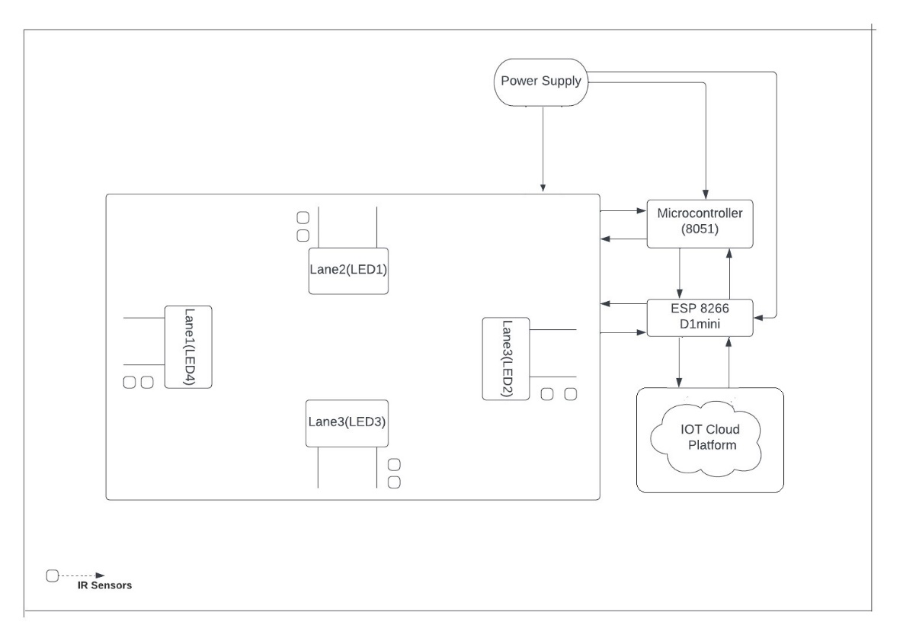

As shown in the Block Diagram on each lane a pair of sensors are planted, the purpose of sensors is to collect data related to traffic density.

* The lights in each lane and the sensors belonging to respective lanes are all connected to several parts of microcontroller 8051.
* The 8051 microcontroller is connected to a development board called as WeMo’s D1 mini, which has a built-in ESP8266 Wi-Fi-module, and operates on a clock speed of 80Mhz/160Mhz.
* The power supply circuit is present which aims in providing required voltage to all the respective blocks as per their requirements.
* The development board D1 mini is integrated with the IOT cloud platform for monitoring and controlling purposes.

Page|4

1. **Circuit diagram and its description**

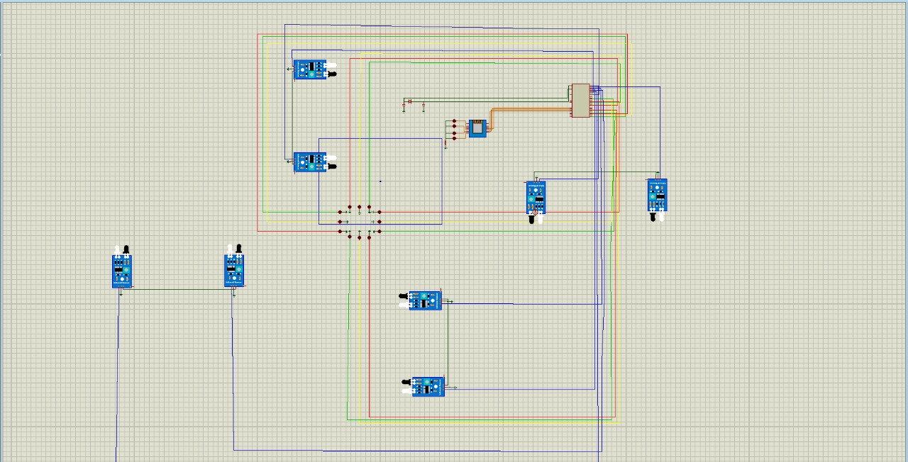

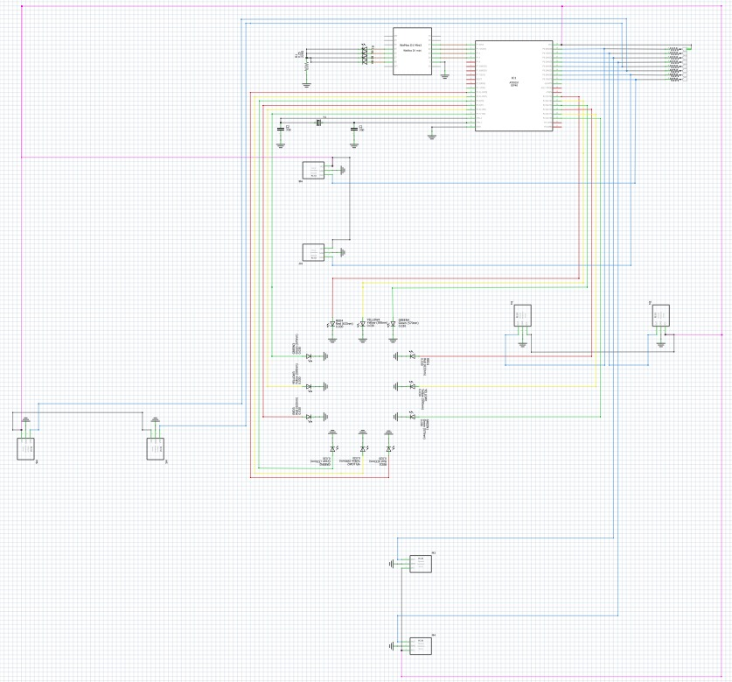

Page|5

**8051 Microcontroller**

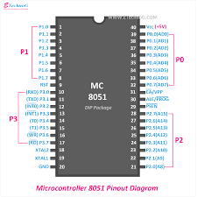

* 4KB bytes on-chip program memory (ROM).
* 128 bytes on-chip data memory (RAM).
* Four register banks.
* 128 user defined software flags.
* 8-bit bidirectional data bus.
* 16-bit unidirectional address bus.
* 32 general purpose registers each of 8-bit.
* 16-bit Timers (usually 2, but may have more or less).
* Three internal and two external Interrupts.
* Four 8-bit ports, (short model have two 8-bit ports).
* 16-bit program counter and data pointer.

Page|6

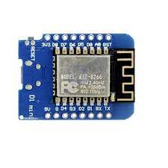**D1-mini Wemos**

* The Wemos D1 Mini is a great development tool for wi-fi based IoT Projects. It uses the popular ESP8266 Module for its IoT operations.
* It can be easily programed via USB and does not require an additional editor.
* Requires a 5 volts of power supply and out of 16 available pins , 9 pins are dedicated for input/output operations.

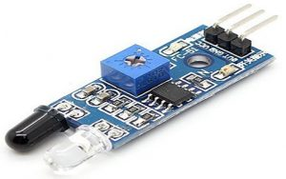**IR-sensor**

* The operating voltage is 5VDC.
* I/O pins – 3.3V & 5V.
* Mounting hole.
* In case of obstacle detection , it gives logic 0 as output.
* In case , when obstacle is not detected , if gives logic 1 as output.

Page|7

1. **PCB Layout and Artwork**

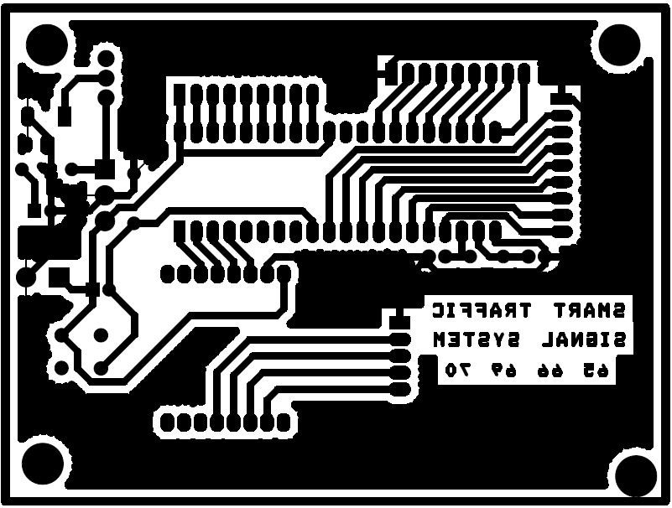

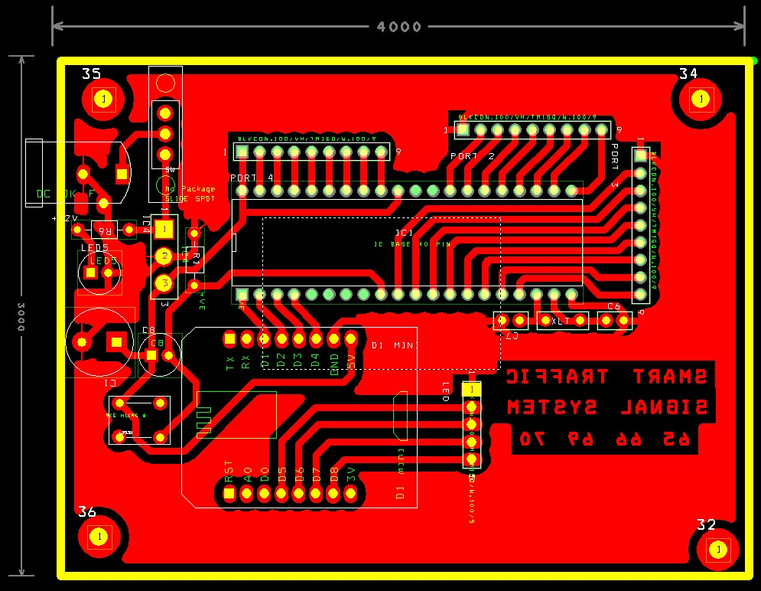

Page|8

* As we can observe from the diagram above , the final size of PCB is approximately around 4-Inches x 3-Inches.
* In the left hand side of the design , the provision for DC-female jack , IC-7805 , Resistors & Capacitors is given.
* The circuit on the left side of design is implemented to step-down the input of 9-volts to 5-volts , or else extra power supply can lead to damage of components.
* Then a copper track is given to supply 5-volts to Vcc pins of 8051 and D-mini respectively.
* In Port-0 , Port-1 , Port-2 & Port-3 of 8051 , footprints for ports is given , for wire connection.
* Similarly , the ports are assigned to the pins of D1-mini for wire connection.
* The PCB design is efficient and compact for the circuit implementation.

1. **Working of Project**

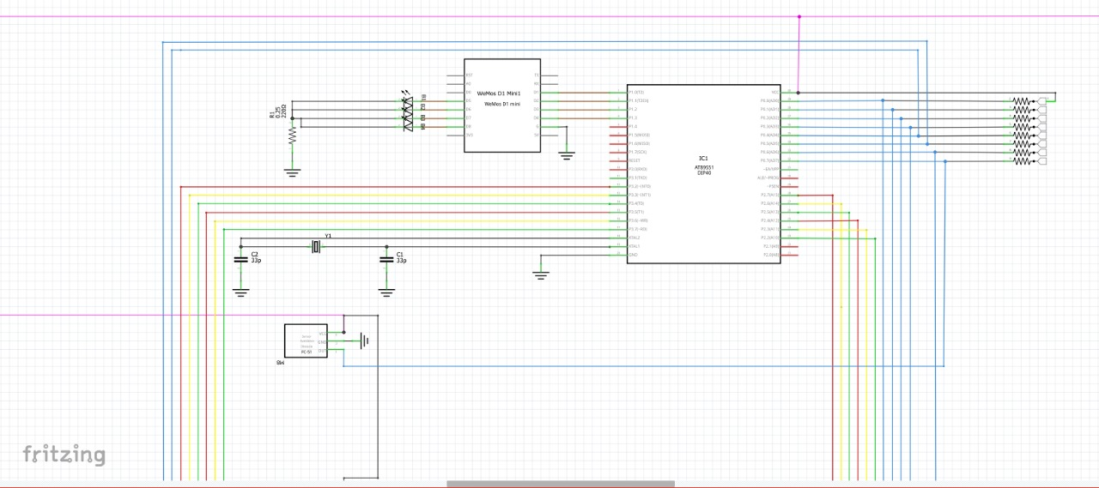

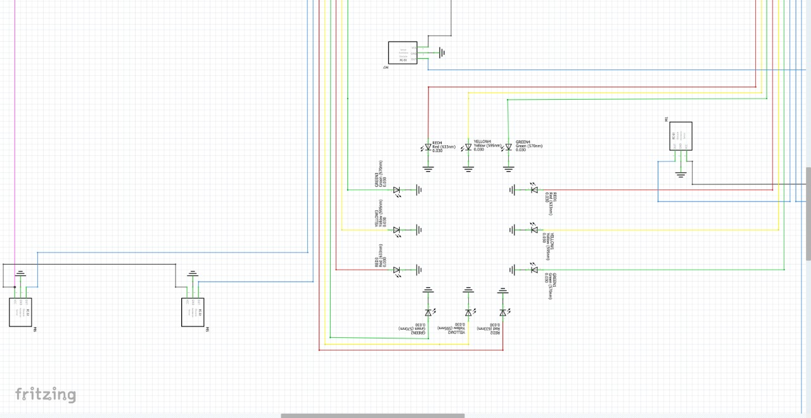

Page|9

Now, as you can see in this above circuit that there are some colored wires, since it is easy to identify the wire which are connected throughout the circuit, where blue wire indicates that they are connected to the sensors, Red-Blue-Green wire are connected to there respective colored led, pink wire is vcc, Brown wire is connect to D1 mini and 8051 and the black wire is grounded.

* As we can see in the above pictures, the port 0 of the micro controller 8051 is connected to the IR sensors.
* In each lane two IR sensors are planted, in order to sense the obstacles.
* So, if the 1st sensor in the particular lane is not sensing then it is considered that traffic density is low in that particular lane.
* So, the 8 pins in total of port 0 of 8051 are completely occupied by IR sensors.
* Port 2 and Port 3 pins of 8051 micro controller are occupied by 12 leds from all the FOUR lanes.
* The four pins of port 1 are connected to development board D1 mini and the job of these four connections is to activate the emergency signal which will be sent to these four pins to activate the emergency green signal in the respective signals.
* The XTAL1 and XTAL2 pins of micro controller 8051 are connected to the crystal oscillator of frequency 11.05912 MHz at the capacitors.

Page|10

1. **Code Implementation and Flowchart :**

* Flowchart for 8051 code implementation :

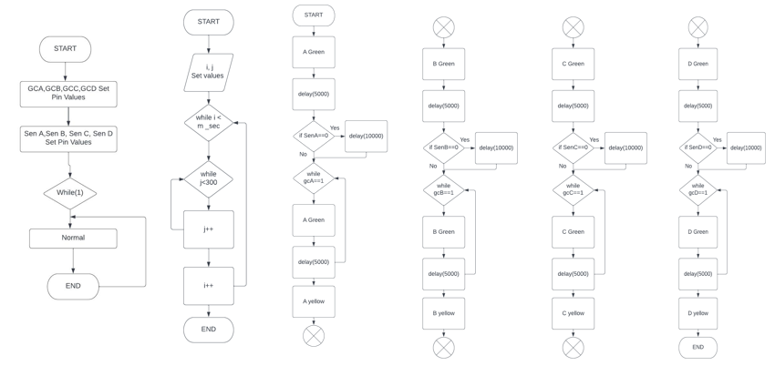

* As , we can observe from the above flowchart , initially , we have declared all the variable names and their corresponding pins.
* Later , we have defined a delay function , which we will be using frequently to give delay wherever required.
* Then , in the main function , we are continuously running normal() function in loop.
* In normal() function , we are turning on RGB lights in all the 4 lanes in a cyclic manner.
* During this , we are checking whether we are getting any interrupt for green corridor at the pins of PORT-1.
* Also , we are checking if there is any obstacle detected at a particular lane by the sensor and if so , then we a providing an extra time for green signal on that lane by calling delay function.

Page|11

* Flowchart for Wemos D1-Mini code implementation :

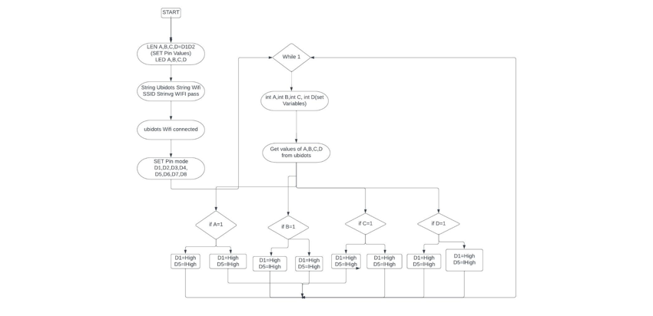

* As, we can observe , in the flowchart above , initially , we have declared variable names and their corresponding pins.
* Later , we have defined strings for UBIDOTS token , Wi-Fi Ssid & Wi-Fi Password.
* Then in the setup() function , we are using pinMode() function in-order to indicate the pins which we will be using will work in input mode or output mode.
* Later , in the loop() function , we are using get() function from UBIDOTS library , to receive value from UBIDOTS dashboard.
* Lastly , according to the values received from dashboard , decision is made whether to activate green corridor and whether to turn on Blue LED for a particular lane using if-else statements.
* If the condition is satisfied , then accordingly High & Low signals are sent to the desired pins of D1-Mini.

Page|12

1. **Result and Future Scope**

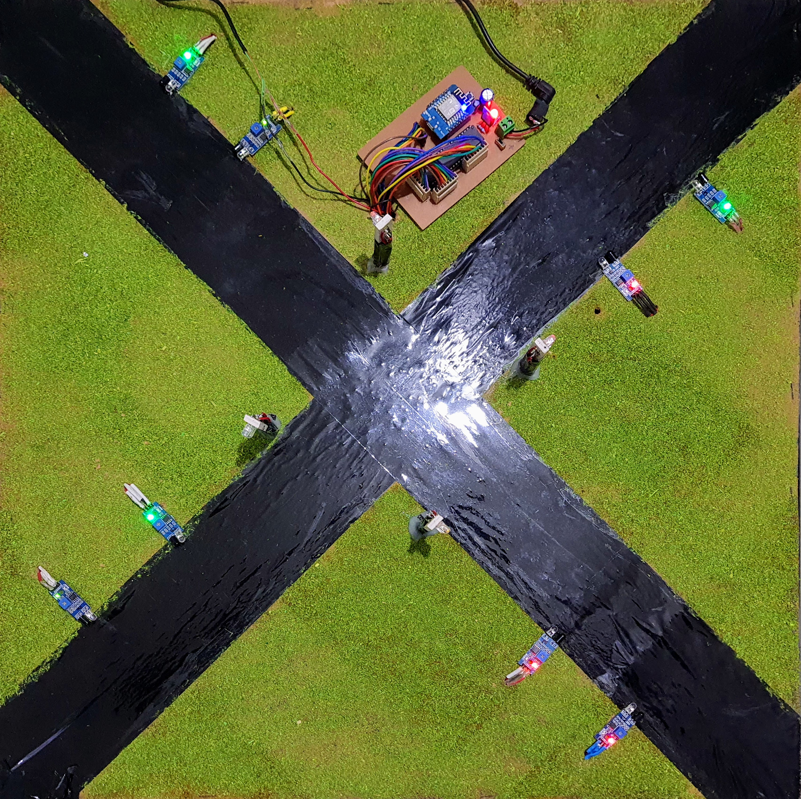 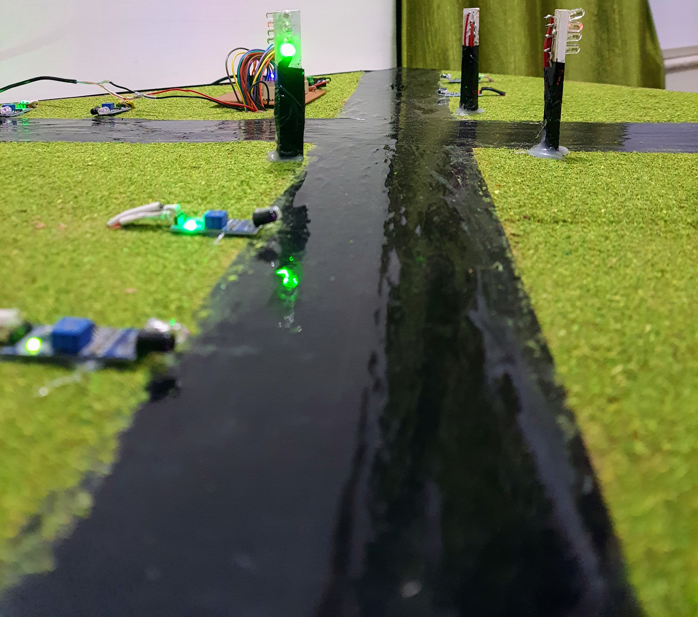

* The circuit designed is running successfully and is showing the desired output.
* The code implementation is perfect and is giving result as per the requirements along with IOT override for green corridor (emergency).
* If the traffic (obstacle) is sensed by the sensor at a particular lane , then immediately a delay for extra time in green signal is observed for that road.
* In future, the brightness of traffic light can be controlled based on the brightness of surrounding light, to make it more energy efficient.
* Also, for the elderly and disabled ones, more crossing time may be provided. This can be implemented using RFID whereby those individuals will be given the card. When these cards are tapped on readers provided, crossing time may be extended.
* Automatic street lighting can be made associated with this to make it more energy efficient too. When the presence of a vehicle or person id detected, the lights can be made brighter.
* For over-speeding, image processing may be used in future projects to make it more accurate.

Page|13

1. **References/ Citations**
2. Ghazal, Bilal, et al. "Smart traffic light control system." *2016 third international conference on electrical, electronics, computer engineering and their applications (EECEA)*. IEEE, 2016.
3. Díaz, Nicole, Jorge Guerra, and Juan Nicola. "Smart traffic light control system." *2018 IEEE Third Ecuador Technical Chapters Meeting (ETCM)*. IEEE, 2018.
4. Hilmani, Adil, Abderrahim Maizate, and Larbi Hassouni. "Automated real-time intelligent traffic control system for smart cities using wireless sensor networks." *Wireless Communications and Mobile Computing* 2020 (2020).
5. Megalingam, Rajesh Kannan, et al. "Smart traffic controller using wireless sensor network for dynamic traffic routing and over speed detection." *2011 IEEE Global Humanitarian Technology Conference*. IEEE, 2011.

Page|14